Name the railroad cars
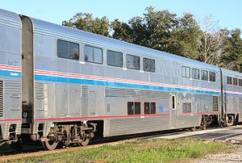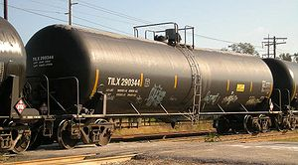

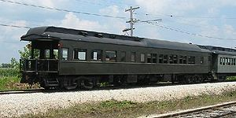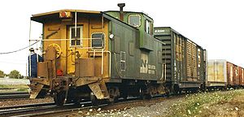

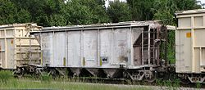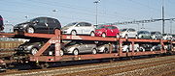

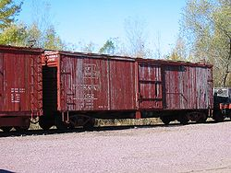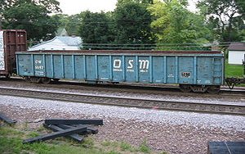

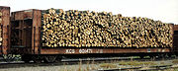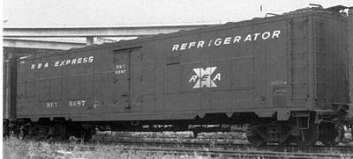

Gondola, autorack, caboose, refrigerator car, tank car, passenger car, observation car, hopper car, box car, flat car
Name three types of modern freight trains.
1)
2)
3)

Explain why unit trains are more efficient than mixed freight trains.

Name one Class I or regional railroad.

What areas of the country does it serve?

What are some hubs/terminals?

What major commodities does it carry?

How does a diesel electric locomotive develops power? Circle the true one.
- The diesel engine connects to the wheels by a transmission like in a car
- The diesel engine drives a pump which moves transmission fluid to drive the wheels
- The diesel engine drives a generator which generates electricity which runs motors which drive the wheels

How does dynamic breaking slow the train? Circle the true one.
- It uses drums or disk breaking system to slow the train like a car does
- It uses the electric motors like generators and either recharges a battery or uses produces heat.
- It switches to low gear to slow the engine like a car does on a downhill

What is radial steering? Circle the true one.
- Ability for the wheels to rotate to conform to the tracks
- Ability for turn quickly
- Using wheel shaped steering rather than levers

Which statement is true regarding mass-transit and rail?
- Rail is an replacement for other mass transit options

- Rail is best when integrated with other mass-transit options.
What is Operation Lifesaver? Circle the true one.
- It is a 911-like phone number posted at each railroad crossing to call if there is a rail-accident.
- It is training all railroad employees get on emergency first-aid including CPR.
- It is a public-education program teaching the public about railroad safety

Cross out the false statements below:
- It is illegal to walk on railroad tracks
- Fewer people are killed by trains than by sharks
- Trains follow a set schedule and therefore will only cross an intersection at a predictable timings.
- There is a phone number on the sign at each crossing to call if there is a malfunction
- If your vehicle stalls on a crossing, the first thing to do is call the railroad to stop the train.

Connect term and what it looks like and means

Advanced Warning Sign You must yield to the train and remain stopped until the lights have
stopped flashing and the gates have lifted.

Pavement markings Have the words "RAILROAD" and "CROSSING" in black and white
assembled in a large "X" configuration.
As you approach, look and listen for an approaching train.

Crossbuck signs Large RXR painted on the pavement.
Stay behind this line to be safe from a train when it passes

Red flashing lights and gates Round, yellow sign bearing the lettering RXR.
Slow down, look and listen for an approaching train.

Connect light color and what it means

Green Used to warn the engineer of an impending stop or speed reduction.

Yellow Used to indicate "clear" track conditions.

Red Used to indicate a full stop or other restrictive condition

What do each of these whistle signals mean?

Short sound?

Two long sounds?

A sustained sound

What does a FRED replace? Circle the true one.K
- The conductor – it is the autopilot of the train
- The caboose – it monitors the train’s state
- The train whistle – it sends digital signals to the station telling of the train’s status

