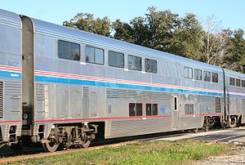
Amtrak Superliner double-decker passenger car

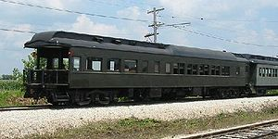
A heavyweight observation on display at the Illinois Railway Museum.

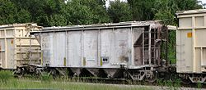
Covered hopper car originally built in the 1950s for the Atlantic Coast Line Railroad. After the 1967 SCL merger these cars were fitted with rotary couplers and used in Bone Valley phosphate service.

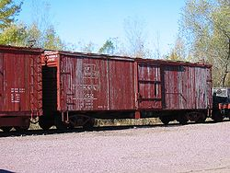
A Duluth, South Shore and Atlantic Railway boxcar on display at the Mid-Continent Railway Museum in North Freedom, Wisconsin.

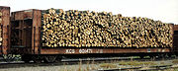
Kansas City Southern Railway #601471, a bulkhead flat car, carries a load of pulpwood.

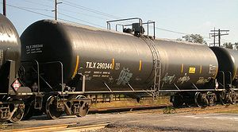
Modern tank cars are designed to carry any liquid or gaseous commodity.

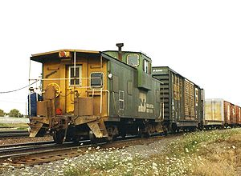
A Burlington Northern Railroad extended vision caboose at the end of a train entering Eola Yard, Aurora, Illinois, in 1993.

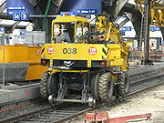
Road-rail excavator

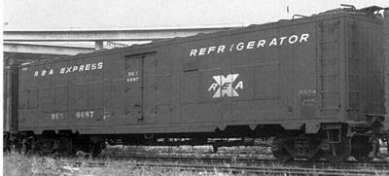
Railway Express Agency refrigerator car #6687, a converted World War II "troop sleeper." Note the square panels along the sides that cover the window openings.

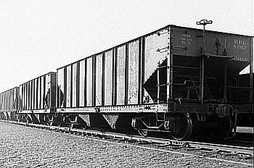
Two-bay hopper cars of the Reading Railroad.

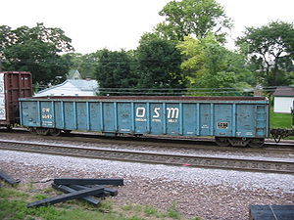
A railroad gondola seen at Rochelle, Illinois.

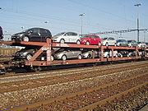
A modern German autorack similar to the original design with a full load of automobiles

